Supplementary Table 1. Distribution diagnostics for interobserver paired differences and nonparametric Bland-Altman results
Metric | Shapiro-Wilk W | P value | Median difference (IQR) | Empirical 95% limits of agreement | 95% bootstrap CI for limits of agreement
TAPSE interobserver paired difference | 0.947 | 0.025 | 0.1 mm (-0.6, 0.8) | (-2.1, 2.5) mm | Lower limit (-2.5, -1.7); upper limit (2.1, 3.0)
PASP interobserver paired difference | 0.938 | 0.012 | 0.8 mmHg (-2.4, 4.5) | (-9.5, 11.6) mmHg | Lower limit (-11.4, -7.8); upper limit (9.8, 13.3)
TAPSE/PASP interobserver paired difference | 0.950 | 0.032 | -0.004 mm/mmHg (-0.025, 0.019) | (-0.083, 0.072) mm/mmHg | Lower limit (-0.098, -0.069); upper limit (0.059, 0.088)
Note: IQR, interquartile range; CI, confidence interval; TAPSE, tricuspid annular plane systolic excursion; PASP, pulmonary artery systolic pressure; TAPSE/PASP, tricuspid annular plane systolic excursion to pulmonary artery systolic pressure ratio. Empirical 95% limits of agreement were defined by the 2.5th and 97.5th percentiles of paired differences; uncertainty in the limits of agreement was estimated using 1,000 bootstrap resamples. W denotes the Shapiro-Wilk normality test statistic; bootstrap CI denotes the uncertainty interval for the limits of agreement estimated using 1,000 bootstrap resamples. P values are from the Shapiro-Wilk normality test.
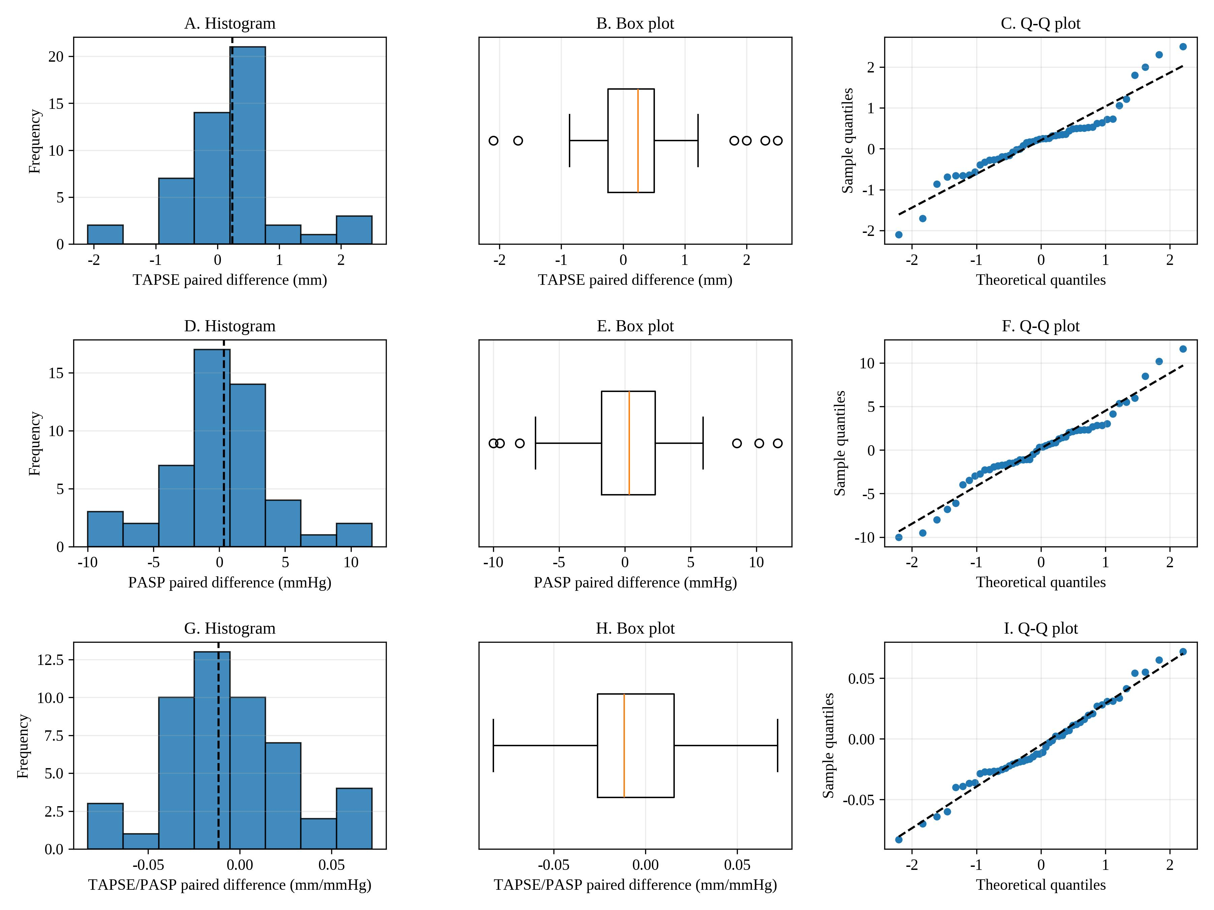
Supplementary Fig. 1. Distribution diagnostic plots for paired interobserver differences in TAPSE, PASP, and TAPSE/PASP among 50 patients included in the interobserver agreement analysis. For each metric, a histogram, box plot, and quantile-quantile (Q-Q) plot are presented; all three paired-difference distributions showed mild skewness or tail deviation, supporting the use of a nonparametric Bland-Altman summary. TAPSE, tricuspid annular plane systolic excursion; PASP, pulmonary artery systolic pressure; TAPSE/PASP, tricuspid annular plane systolic excursion to pulmonary artery systolic pressure ratio.

